**St Margaret’s at Hasbury Church of England Primary School**

Hagley Road, Halesowen, West Midlands B63 4QD

**Headteacher**: Mrs S Shepherd

**Tel**: 01384 818660 **Emai**l: [info@hasbury.dudley.sch.uk](mailto:info@hasbury.dudley.sch.uk)

2nd February 2022

Dear Parents,

It seems like a long time until the summer returns but here, at St. Margaret’s at Hasbury, we are looking ahead to planning for our Year 6 leavers.

This year, School will be purchasing leavers hoodies for all of our Year 6 children so there will be no cost to yourselves.

Please have a look at the size guide below, complete the slip with the size that you would like for your child and return to school by Wednesday 9th February 2022.

Size

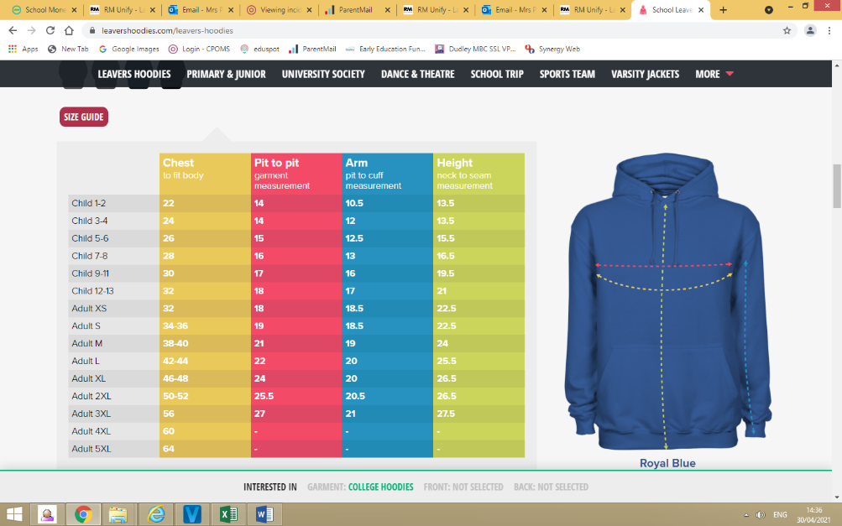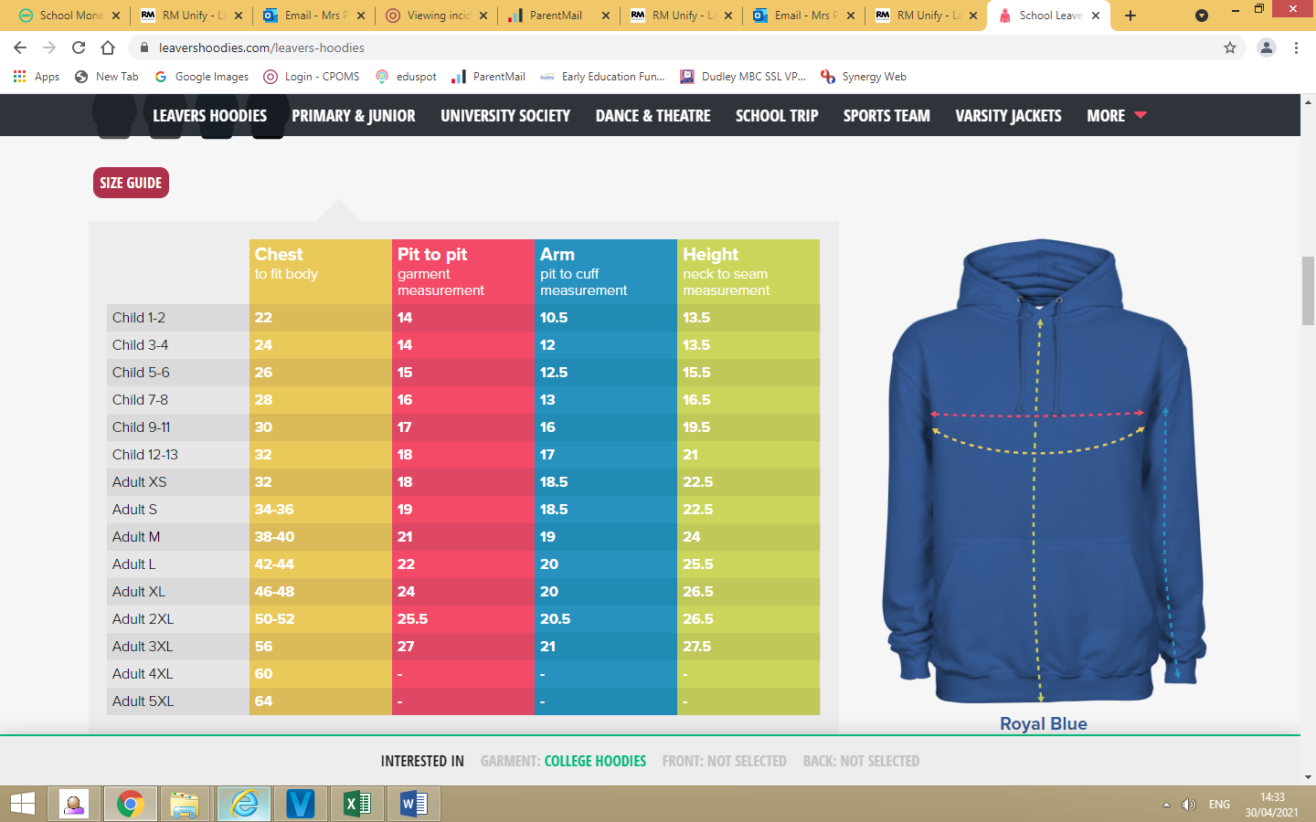

Measurements in inches

The hoodies should arrive in time for the last half term of Year 6, and Year 6 will be able to wear their hoodies as school uniform for their final half term.

Yours sincerely,

Mrs Shepherd

Headteacher

**Year 6 Leavers Hoodies 2022**

**Please return to school by Wednesday 9th February 2022**

Child’s Name__________________________________________________

Size Required (i.e. Child 9-11) ____________________________________

Parent Signature_______________________________________________